Final exam q1

Mehrab Atighi

1/12/2022

# multivariate 2 final exam codes: qestion :6  
library(MASS)  
data = read.table("F:/lessons/Multi countios Variate2/data/gandom.txt")  
data = t(data)  
colnames(data) = c("Cambridge" , "Cockle Park" ,"Harpers Adams" , "Headley Hall" ,"Morley","Myerscough" ,"Rosemaund" , "Seale-Hayne" ,"Seale-Hayne" , "Sutton Bonington" ,"Terrington" , "Wye")  
  
  
(Dist1 = dist(data , method = "euclidean",  
 diag = TRUE , upper = TRUE))

## V1 V2 V3 V4  
## V1 0.00000 34.52965 39.34903 40.20390  
## V2 34.52965 0.00000 43.91066 32.64609  
## V3 39.34903 43.91066 0.00000 49.59618  
## V4 40.20390 32.64609 49.59618 0.00000

model1 = hclust(Dist1 , method = "ward.D")  
model1

##   
## Call:  
## hclust(d = Dist1, method = "ward.D")  
##   
## Cluster method : ward.D   
## Distance : euclidean   
## Number of objects: 4

plot( model1 , hang = -1 )  
  
library(factoextra)

## Loading required package: ggplot2

## Welcome! Want to learn more? See two factoextra-related books at https://goo.gl/ve3WBa

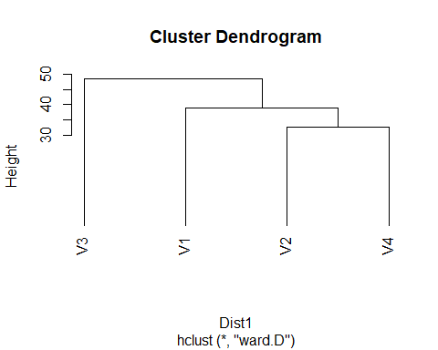

library(gridExtra)  
  
model2 = kmeans(data , 3 , algorithm = "Hartigan-Wong")  
model3 = kmeans(data , 3 , algorithm = "Lloyd")  
model4 = kmeans(data , 3 , algorithm = "Forgy")  
model5 = kmeans(data , 3 , algorithm = "MacQueen")  
  
  
p1 <- fviz_cluster(model2, geom = "point", data = data) + ggtitle("way = 1")  
p2 <- fviz_cluster(model3, geom = "point", data = data) + ggtitle("way = 2")  
p3 <- fviz_cluster(model4, geom = "point", data = data) + ggtitle("way = 3")  
p4 <- fviz_cluster(model5, geom = "point", data = data) + ggtitle("way = 4")  
grid.arrange(p1, p2, p3, p4, nrow = 2)

